Masorti Judaism AGM 2025 – New Trustees’ Biographies

Jude Williams

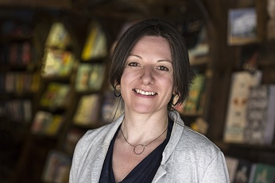

I am standing as a Masorti trustee because I believe deeply in our thoughtful Jewish community grounded in tradition, learning, and social responsibility. Having lived and worked in both Israel and the UK, I bring decades of experience in Jewish education, youth movements, and community development.
After making Aliyah in 1994, I worked in the Jewish Agency and with all the Zionist Youth Movements, as an educator and programme director. I received my Master's from Hebrew University during that time. I am a Jerusalem Fellow at the Mandel School, specialising in Jewish identity and community building in young adults.
On returning to the UK, I worked as Director of Education, strengthening synagogue provision, the youth movement and young adult engagement in Reform Judaism, including founding Jeneration. Now Chief Executive at a literacy charity and Chair of trustees at a youth charity, I understand the demands of charity fundraising, communications and strategy building, as well as the responsibilities of good governance.
Masorti Judaism’s principled yet open approach resonates deeply with my values, and I am eager to contribute my experience to help strengthen its future.

Vikki Bullon

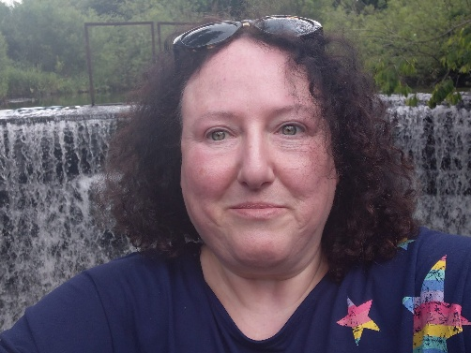

I am originally from Glasgow & joined SAMS 15 years ago. I wanted to bring up my daughter in a modern Jewish egalitarian community and as soon as I visited SAMS, I felt like we belonged.
My daughter has been through Cheder & the Bat Mitzvah programme but most importantly to her Jewish identity, Noam camp. Being part of the Masorti movement has shaped us as a family, especially as most of our relatives are overseas.
I have been a member of the SAMS marketing committee and I was the Membership Officer for a few years. This was really interesting as I had the opportunity to meet so many people as they became part of the Masorti movement.
Professionally, I worked in higher education for twenty years lecturing in marketing & managing university partnerships.
I think this is a critical time for the Jewish community in Britain and I am excited to join the Board of Trustees as an opportunity to be part of the future direction of Masorti UK.

Ruti Amal

Details to follow

